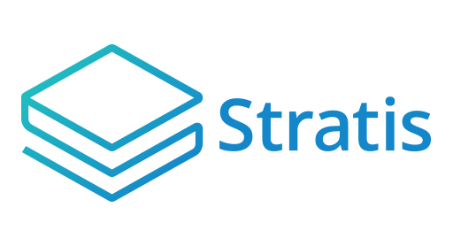

**<YOUR_ICO>**

User Guide

**Table of Contents**

**Introduction** 3

**Signing up for the <your_ICO>** 4

**Completing the Onfido KYC** 6

**Making a contribution** 9

**Making contributions using Changelley** 9

**Two-factor authentication** 12

**Withdrawing your contributions** 14

# **Introduction**

The Initial Coin Offering (ICO) Platform is a web-based application that allows you to earn <your_company > tokens (<your_tokens>) at the point of initial allocation. <your_tokens> are earned by making contributions in either BTC or STRAT. [Changelly](https://changelly.com/) is also integrated into the ICO Platform, and you can use this service to convert other cryptocurrencies into STRAT before contributing.

<your_company> uses [Onfido](https://onfido.com/) for identify verification. This guide provides step by step instructions on how to complete this process, so you can begin making contributions.

For your own security, you can also set up 2-Factor Authentication, and this guide shows you how to do this.

Once the <your_ICO> is complete, you can withdraw the <your_tokens> that you earned through your contributions. This guide includes a chapter on how to do this.

# **Signing up for the <your_ICO>**

To register, navigate to the <your_ICO> page:

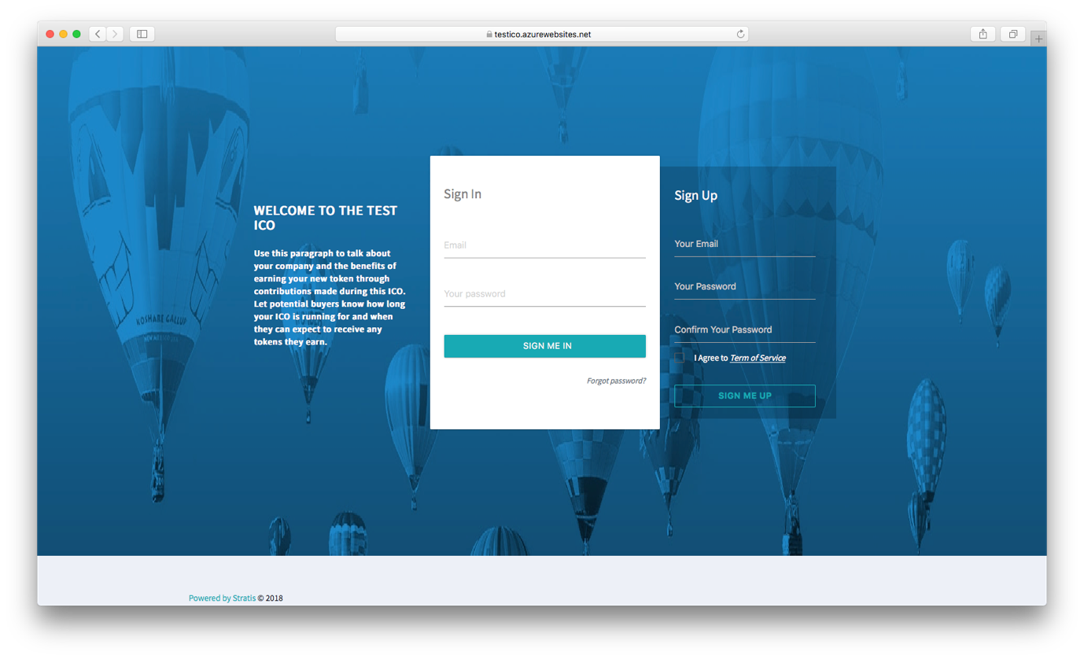

Sign up to the platform by entering your email, a password, and a password confirmation.

**Note**

Your password must be at least 8 characters, have at least one non-alphanumeric character, have at least one digit (‘0’-‘9’), and have at least one uppercase letter (‘A’-‘Z’).

You will receive a confirmation email with a link back to the <your_ICO> Login page. Click on the link to confirm your account and then sign in using your email and password. The Dashboard page is then displayed:

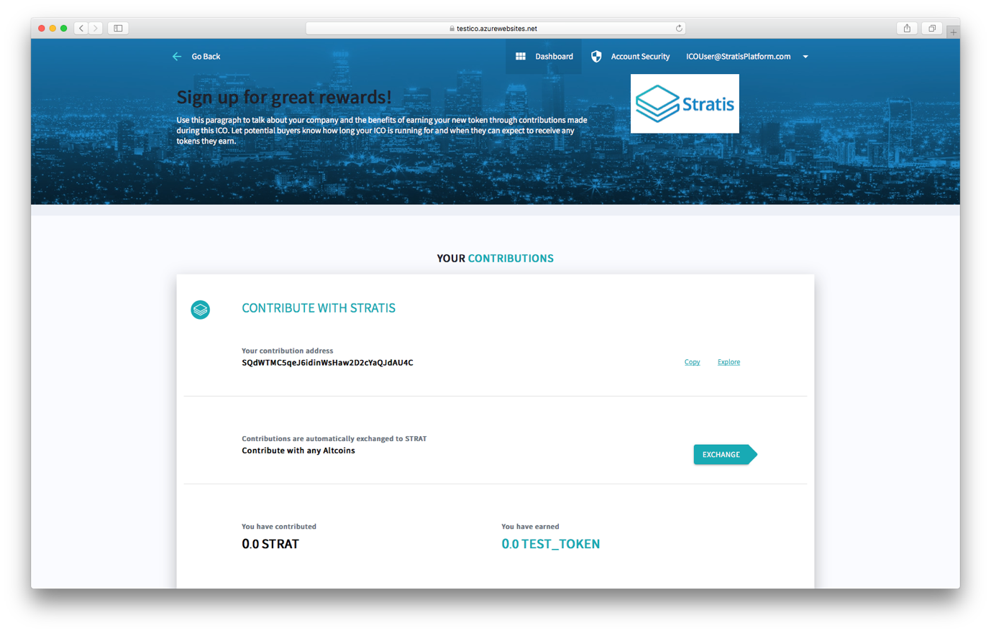

**Note**

You can change your password on the Account Security page.

# **Completing the Onfido KYC**

When you first go to the Dashboard page, the following is displayed:

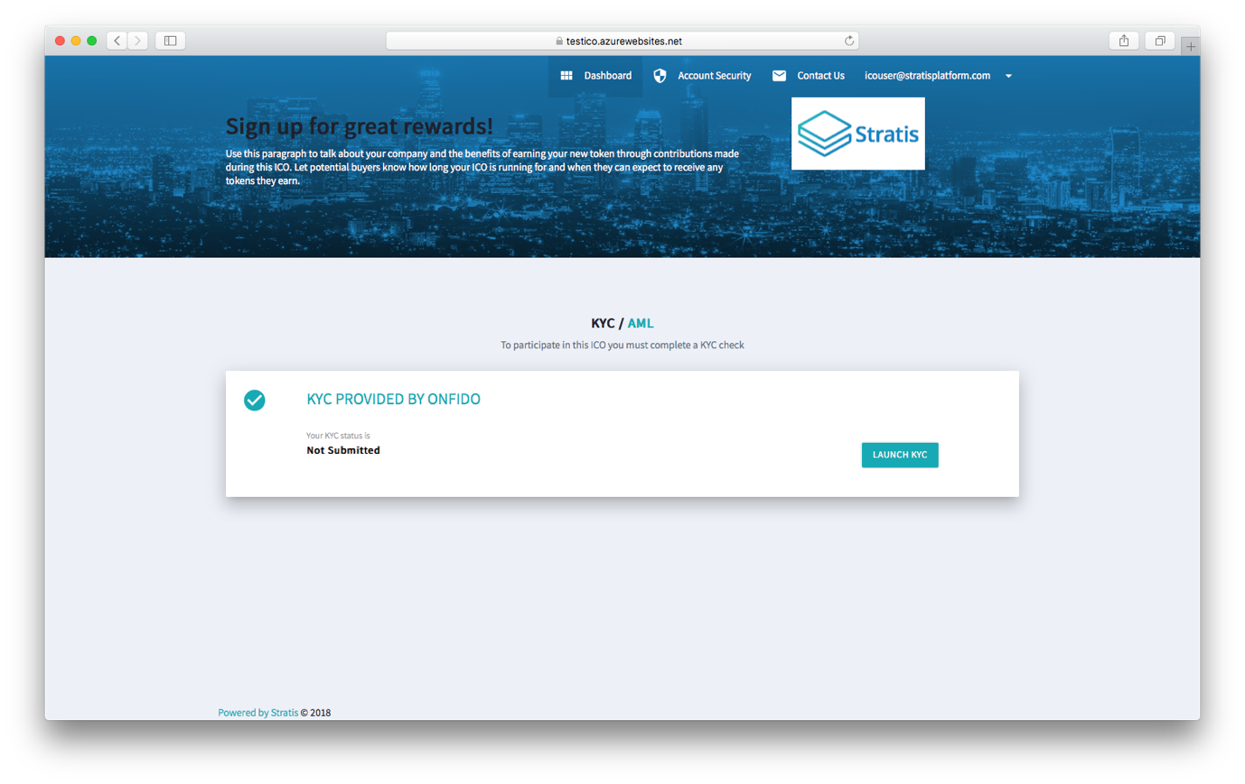

Before contributing, you must complete a KYC check provided by Onfido. Click the *Launch KYC* button. You are prompted to enter your personal information:

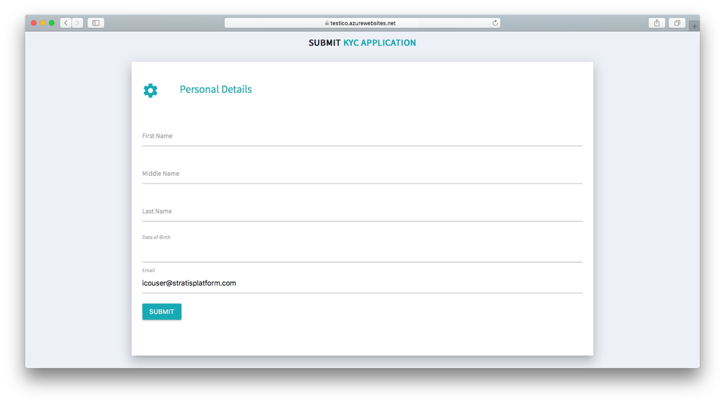

Click the *Submit* button. One or both of the following happens:

1. You are directed to the Onfido site to complete the verification process.
2. You receive a link to the Onfido site in an email.

The following figure shows the first page of the verification process on the Onfido site:

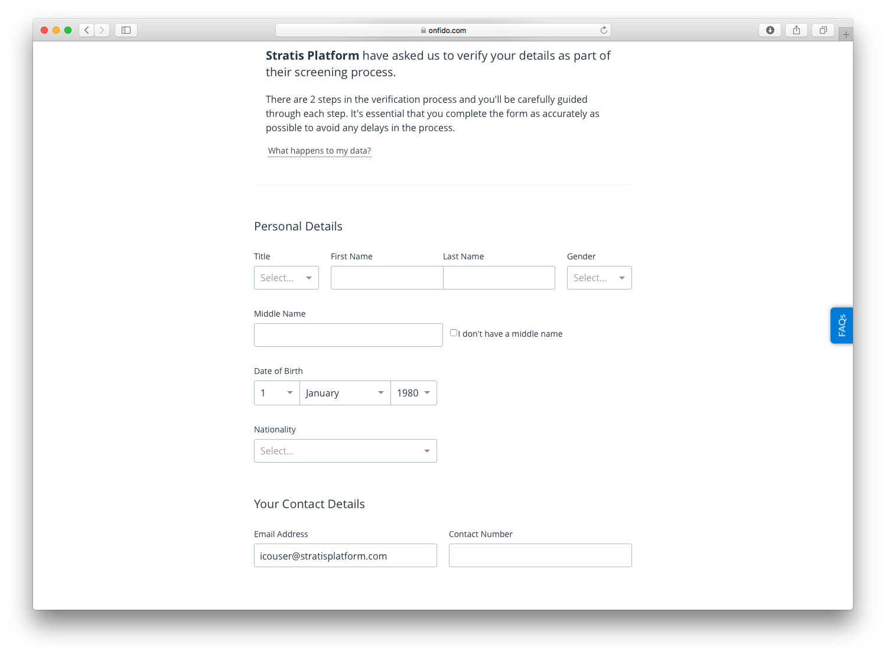

The next step involves submitting photographs of your passport or driving license. Move through the Onfido verification process. The status of your KYC application is updated on the Dashboard page:

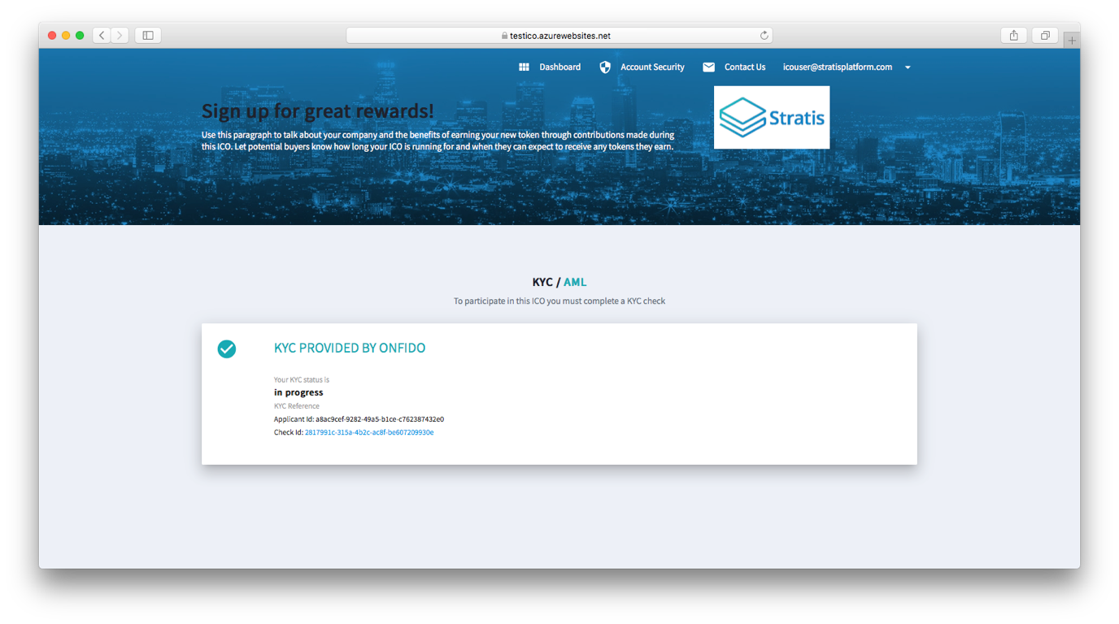

Clicking the *Check Id* hyperlink navigates to the Verification Process page on the Onfido site. Until verification has been completed, no other information is available on the Dashboard page. If you encounter any difficulties in passing the verification process, please click the *ContactUs* link at the top of the Dashboard page and report your situation.

# **Making a contribution**

When you first go to the Dashboard page/Once you have completed the KYC, the following is displayed:

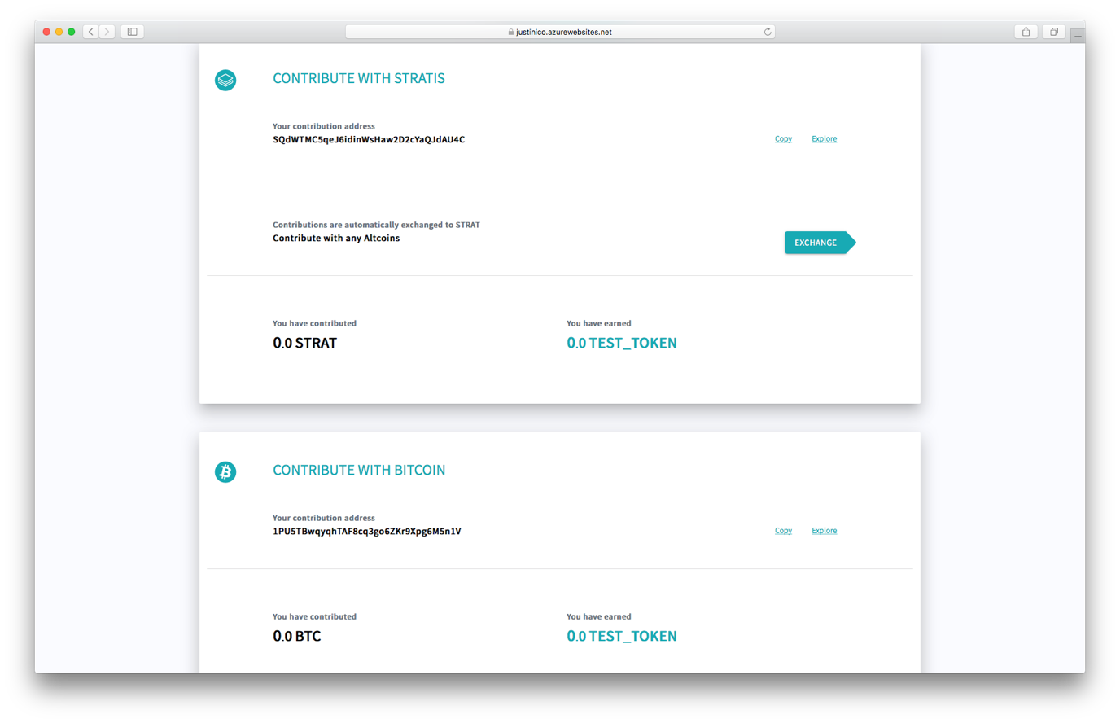

To contribute in either BTC or STRAT, copy the relevant contribution address and use it to send a contribution. The exact procedure for this varies according to the wallet you are using. After the transaction has been confirmed, which takes approximately 10 minutes for BTC and 1 minute for STRAT, the Dashboard page displays your contribution and the <your_tokens> you have earned.

Clicking explore takes you to BTC and STRAT blockchain explorers powered by cryptoID.

## **Making contributions using Changelley**

To make a contribution using Changelley, click on the *Exchange* button in the Contribute With Stratis panel. The following page is displayed in a new browser window:

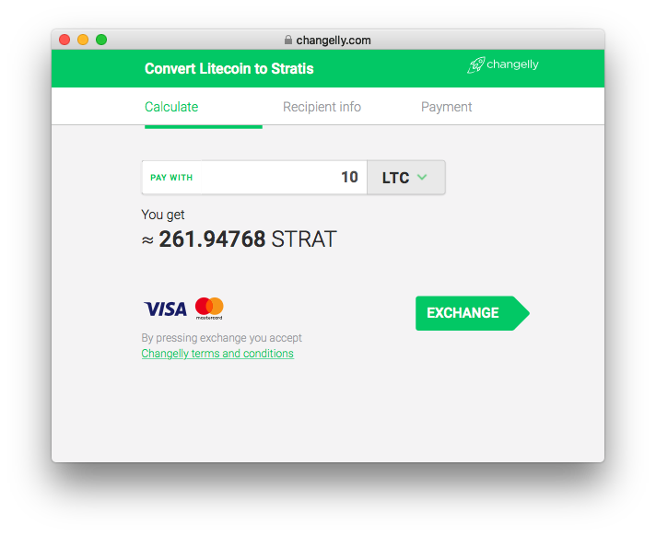

Choose the altcoin you want to contribute with and the amount. In this example, 10 Litecoin are contributed. Click the *Exchange* button. You will see the following:

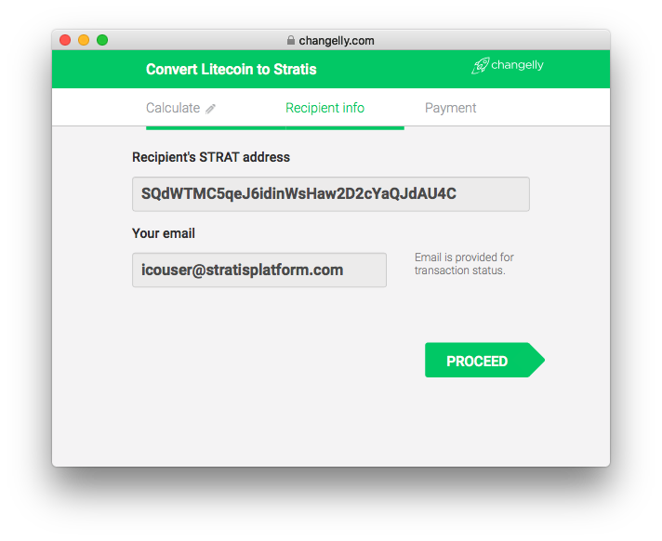

The contribution STRAT address is automatically added to the box. Add your email address and click the *Proceed* button. You will see the following:

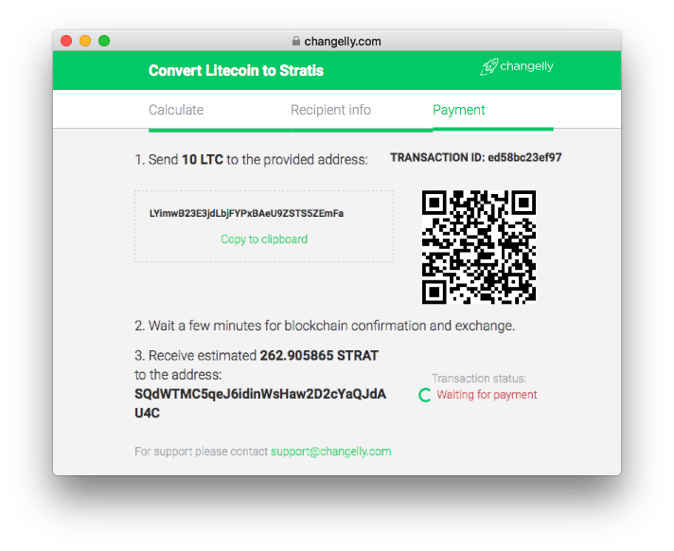

Send the altcoin to the provided address and a contribution in STRAT, very close to the estimated value given, is made for you.

# **Two-factor authentication**

For added security, you can use the Google Authenticator to enable two-factor authentication. To do this, navigate to the Account Security page and click the *Enable* button.

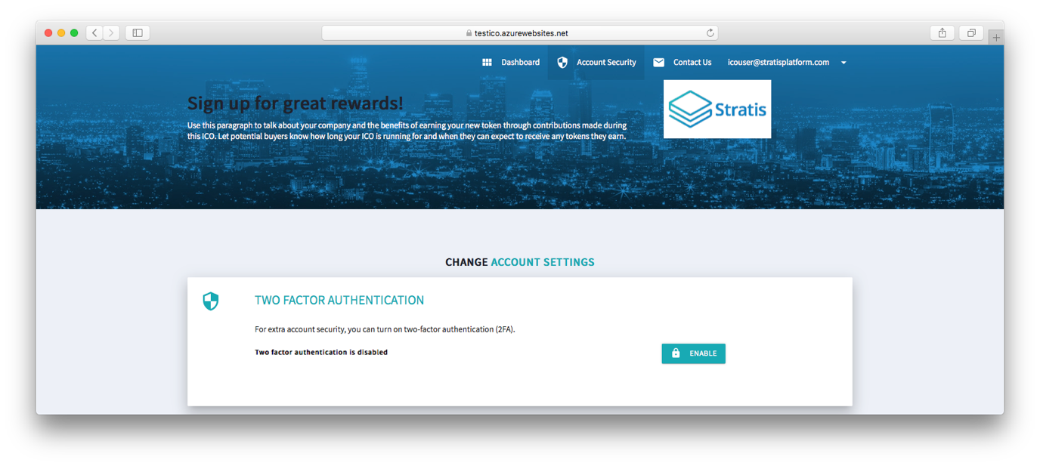

Follow the instructions displayed on the page:

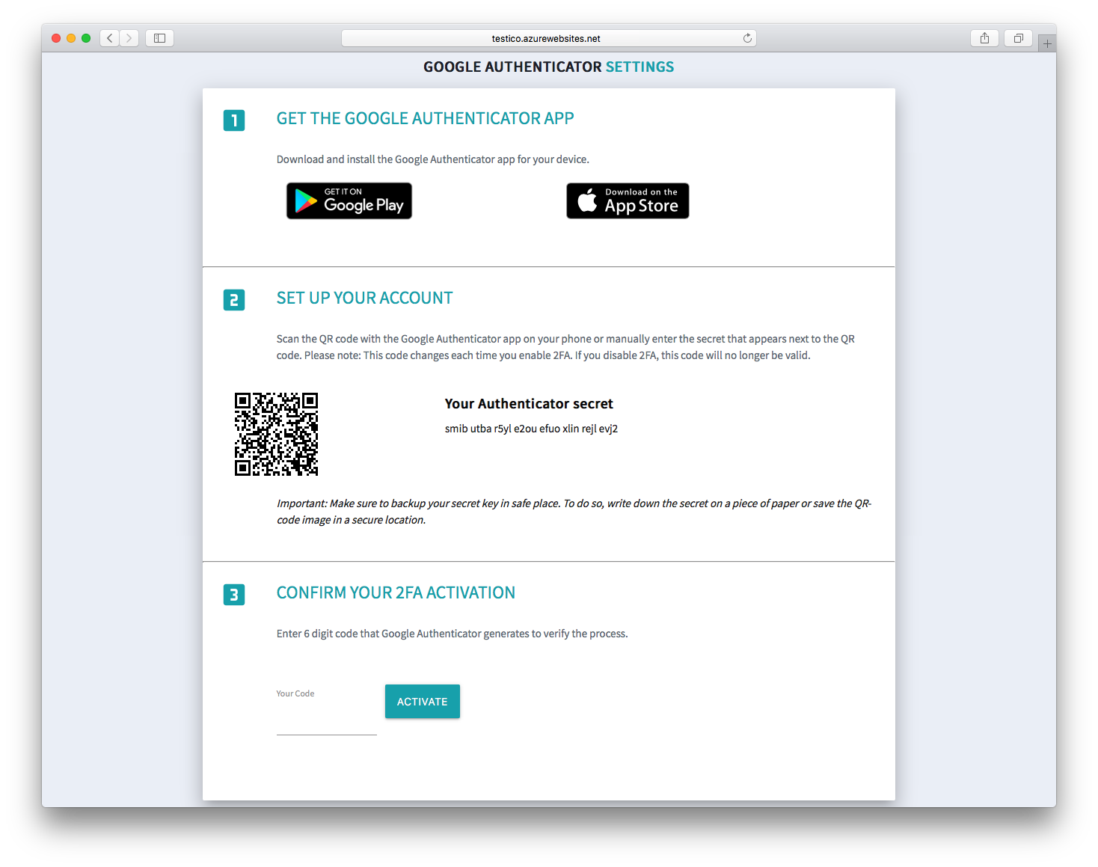

When two-factor authentication is running, you are asked to enter the 6 digit code from the Google Authenticator app when you log in. If you decide that you no longer require it, you can turn off two-factor authentication on the Account Security page.

# **Withdrawing your contributions**

When the <your_company > ICO has ended, you will be able to withdraw the <your_tokens> you have earned. At the end of the ICO, <your_company> will make a <your_tokens> wallet available to you. From this wallet, you can obtain a <your_tokens> address and use it to withdraw your <your_tokens>.

At the end of the ICO, a box is displayed at the bottom of Dashboard page showing the total <your_tokens> you have earned:

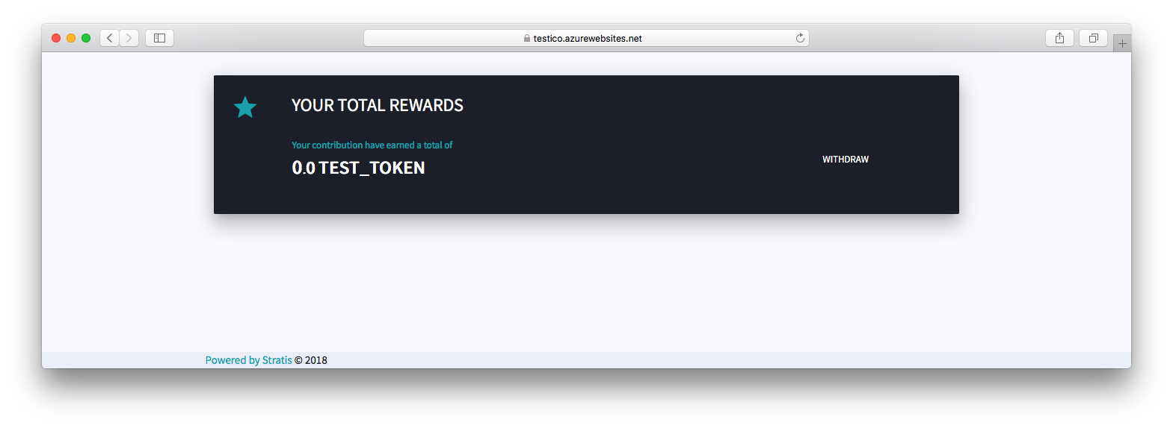

Click the *Withdraw* button and submit your <your_tokens> address to withdraw your <your_tokens> tokens.